Civil war in Georgia

UNSC Resolution: | 1462
Date of adoption: | 01/30/03
Operative paragraph: | 7
Demand number: | 1462.0711

David Siroky

Wording of demand

receive the "Basic Principles for the Distribution of Competencies between Tbilisi and Sukhumi" and its transmittal letter

List of addressees of the demand

Government of Georgia, Abkhazia

Short-term compliance

Description of the addressee(s)’ conduct

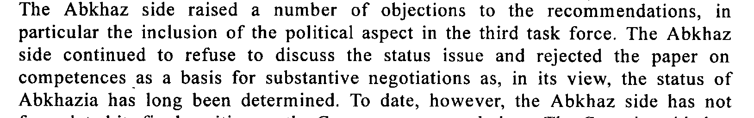

Assessment

s/2003/412

Short-term compliance
No or marginal compliance (1) | Medium low compliance (2) | Medium high compliance (3) | Full or almost full compliance (4)

Considerations underlying the assessment

Medium-term compliance

Description of the addressee(s)’ conduct

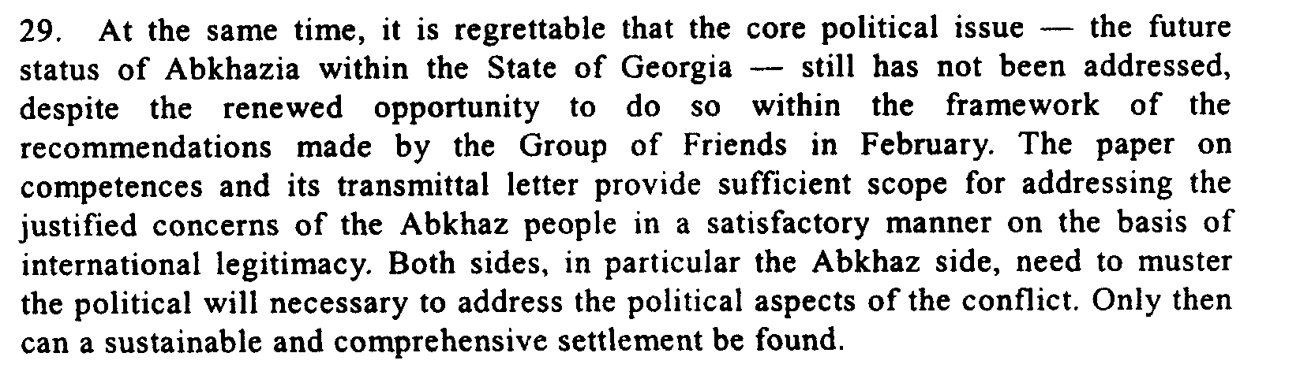
S/2003/412

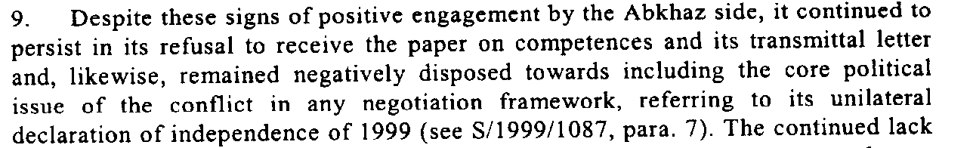
s/2003/1019

Assessment

Medium-term compliance
No or marginal compliance (1) | Medium low compliance (2) | Medium high compliance (3) | Full or almost full compliance (4)

Considerations underlying the assessment

Depth of demand

Assessment

Level of depth of demand
Low depth of demand (1) | Medium depth of demand (2) | High depth of demand (3)

Considerations underlying the assessment

Level of confidence about coding decisions

Level of confidence about coding decision
Extremely high | High | Moderate

Comments to IPI (if any)

Civil war in Georgia

UNSC Resolution: | 1462
Date of adoption: | 01/30/03
Operative paragraph: | 7
Demand number: | 1462.0712

David Siroky

Wording of demand

give "Basic Principles for the Distribution of Competencies between Tbilisi and Sukhumi" full and open consideration and engage in constructive negotiations on their substance

List of addressees of the demand

Government of Georgia, Abkhazia

Short-term compliance

Description of the addressee(s)’ conduct

s/2003/412

Assessment

Short-term compliance
No or marginal compliance (1) | Medium low compliance (2) | Medium high compliance (3) | Full or almost full compliance (4)

Considerations underlying the assessment

Medium-term compliance

Description of the addressee(s)’ conduct

s/2003/412

s/2003/1019

Assessment

Medium-term compliance
No or marginal compliance (1) | Medium low compliance (2) | Medium high compliance (3) | Full or almost full compliance (4)

Considerations underlying the assessment

Depth of demand

Assessment

Level of depth of demand
Low depth of demand (1) | Medium depth of demand (2) | High depth of demand (3)

Considerations underlying the assessment

Level of confidence about coding decisions

Level of confidence about coding decision
Extremely high | High | Moderate

Comments to IPI (if any)

Civil war in Georgia

UNSC Resolution: | 1462
Date of adoption: | 01/30/03
Operative paragraph: | 9
Demand number: | 1462.0911

David Siroky

Wording of demand

spare no efforts to overcome ongoing mutual mistrust of the other party

List of addressees of the demand

Government of Georgia, Abkhazia

Short-term compliance

Description of the addressee(s)’ conduct

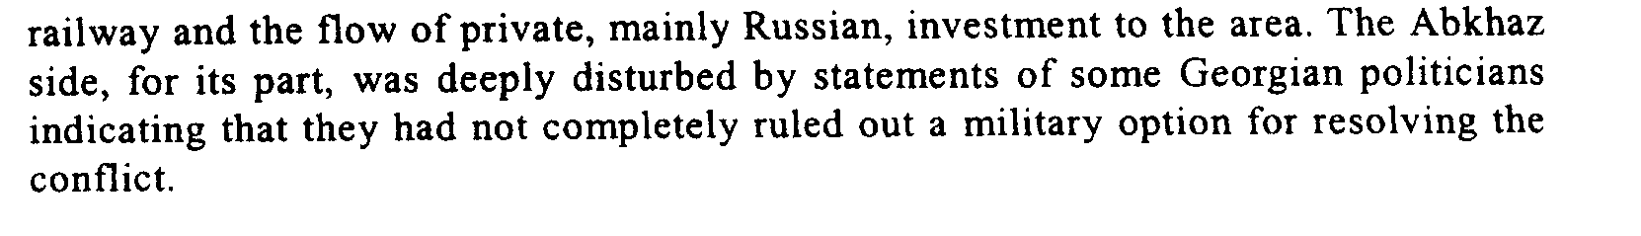
s/2003/751

Assessment

Short-term compliance
No or marginal compliance (1) | Medium low compliance (2) | Medium high compliance (3) | Full or almost full compliance (4)

Considerations underlying the assessment

Medium-term compliance

Description of the addressee(s)’ conduct

S/2003/751

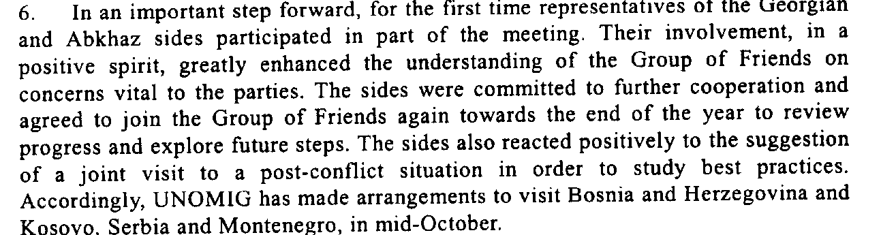
s/2003/751

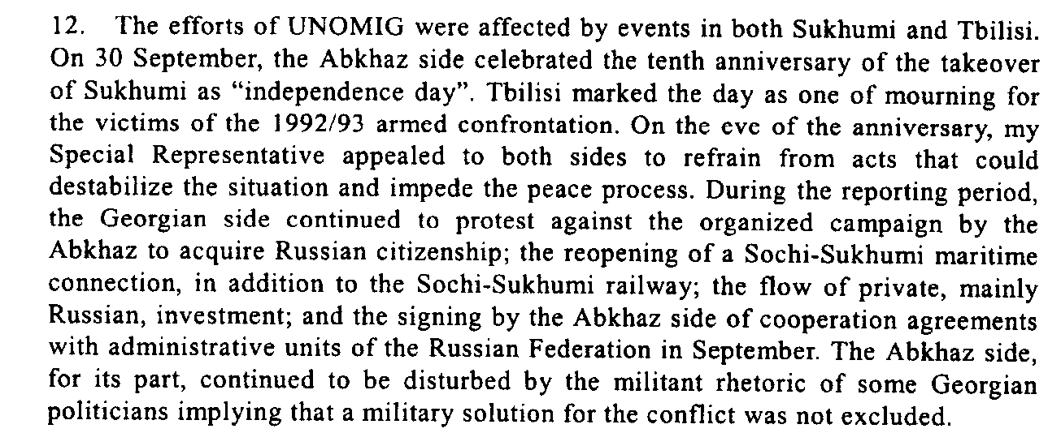
s/2003/1019

Assessment

Medium-term compliance
No or marginal compliance (1) | Medium low compliance (2) | Medium high compliance (3) | Full or almost full compliance (4)

Considerations underlying the assessment

Depth of demand

Assessment

Level of depth of demand
Low depth of demand (1) | Medium depth of demand (2) | High depth of demand (3)

Considerations underlying the assessment

Level of confidence about coding decisions

Level of confidence about coding decision
Extremely high | High | Moderate

Comments to IPI (if any)

Civil war in Georgia

UNSC Resolution: | 1462
Date of adoption: | 01/30/03
Operative paragraph: | 11
Demand number: | 1462.1111

David Siroky

Wording of demand

continue to fully implement protocol signed on 2 April 2002 regarding the situation in the Kodori Valley (especially the Georgian party) and spare no efforts to agree on a mutually acceptable arrangement for the security of the population in, and in the vicinity of, the Kodori Valley

List of addressees of the demand

Government of Georgia, Abkhazia

Short-term compliance

Description of the addressee(s)’ conduct

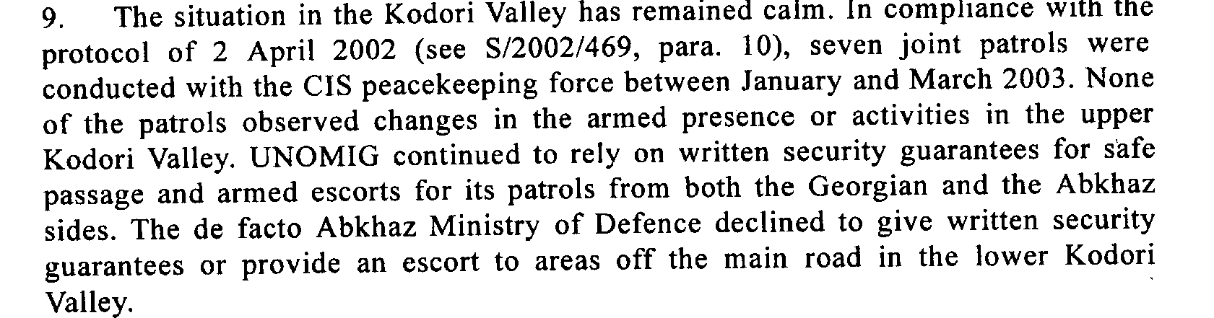

s/2003/412

Assessment

Short-term compliance
No or marginal compliance (1) | Medium low compliance (2) | Medium high compliance (3) | Full or almost full compliance (4)

Considerations underlying the assessment

Medium-term compliance

Description of the addressee(s)’ conduct

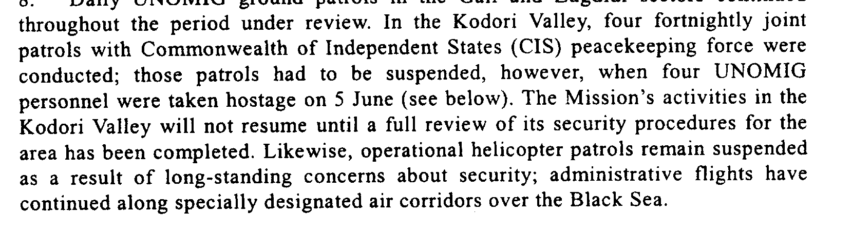

s/2003/751

Assessment

Medium-term compliance
No or marginal compliance (1) | Medium low compliance (2) | Medium high compliance (3) | Full or almost full compliance (4)

Considerations underlying the assessment

Depth of demand

Assessment

Level of depth of demand
Low depth of demand (1) | Medium depth of demand (2) | High depth of demand (3)

Considerations underlying the assessment

Level of confidence about coding decisions

Level of confidence about coding decision
Extremely high | High | Moderate

Comments to IPI (if any)

Civil war in Georgia

UNSC Resolution: | 1462
Date of adoption: | 01/30/03
Operative paragraph: | 12
Demand number: | 1462.1211

David Siroky

Wording of demand

continue to improve security for joint UNOMIG and CIS peacekeeping force patrols in the Kodori Valley to enable them to monitor the situation independently and regularly

List of addressees of the demand

Government of Georgia, Abkhazia

Short-term compliance

Description of the addressee(s)’ conduct

s/2003/412

Assessment

Short-term compliance
No or marginal compliance (1) | Medium low compliance (2) | Medium high compliance (3) | Full or almost full compliance (4)

Considerations underlying the assessment

Medium-term compliance

Description of the addressee(s)’ conduct

NA

Assessment

Medium-term compliance
No or marginal compliance (1) | Medium low compliance (2) | Medium high compliance (3) | Full or almost full compliance (4)

Considerations underlying the assessment

Depth of demand

Assessment

Level of depth of demand
Low depth of demand (1) | Medium depth of demand (2) | High depth of demand (3)

Considerations underlying the assessment

Level of confidence about coding decisions

Level of confidence about coding decision
Extremely high | High | Moderate

Comments to IPI (if any)

Civil war in Georgia

UNSC Resolution: | 1462
Date of adoption: | 01/30/03
Operative paragraph: | 13
Demand number: | 1462.1311

David Siroky

Wording of demand

ensure the necessary revitalization of the peace process in all its major aspects, to resume work in the Coordinating council and its relevant mechanisms, to build on the results of the Yalta meeting on confidence-building measures, and to implement the proposals agreed on that occasion in a purposeful and cooperative manner, and to consider holding a fourth conference on confidence-building measures

List of addressees of the demand

Government of Georgia, Abkhazia

Short-term compliance

Description of the addressee(s)’ conduct

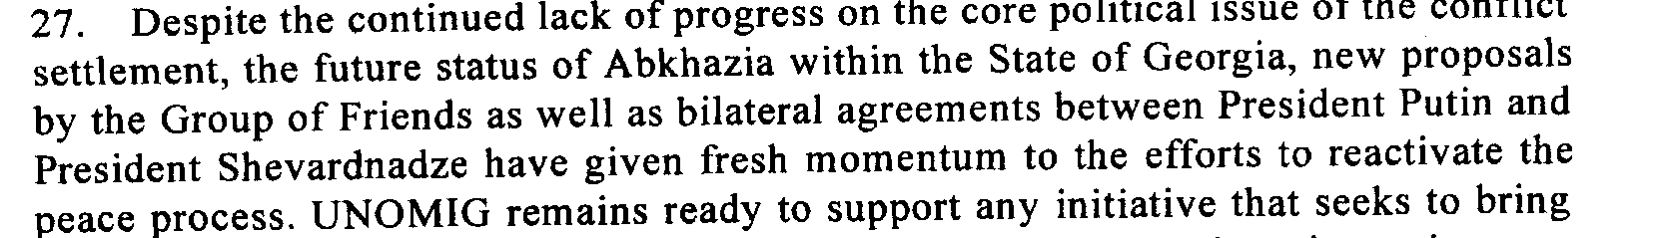

s/2003/412

Assessment

Short-term compliance
No or marginal compliance (1) | Medium low compliance (2) | Medium high compliance (3) | Full or almost full compliance (4)

Considerations underlying the assessment

Medium-term compliance

Description of the addressee(s)’ conduct

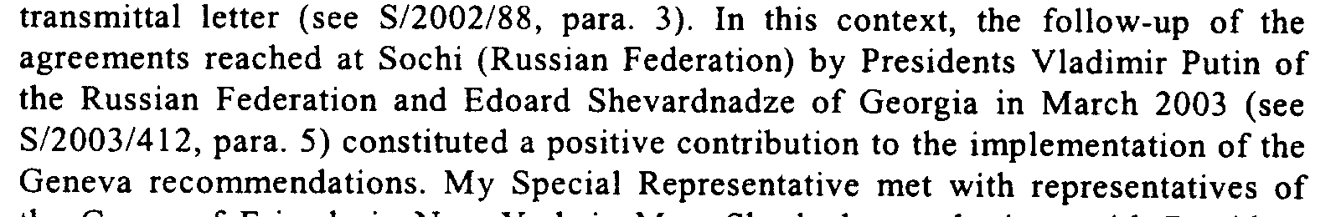

s/2003/412

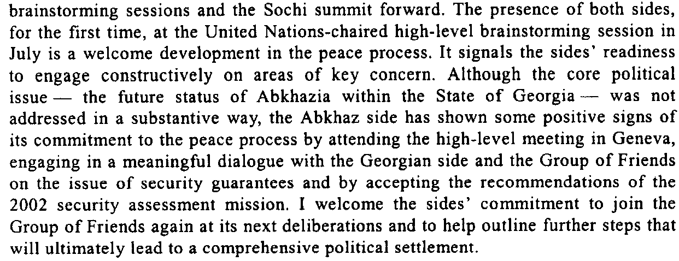
s/2003/1019

Assessment

Medium-term compliance
No or marginal compliance (1) | Medium low compliance (2) | Medium high compliance (3) | Full or almost full compliance (4)

Considerations underlying the assessment

Depth of demand

Assessment

Level of depth of demand
Low depth of demand (1) | Medium depth of demand (2) | High depth of demand (3)

Considerations underlying the assessment

Level of confidence about coding decisions

Level of confidence about coding decision
Extremely high | High | Moderate

Comments to IPI (if any)

Civil war in Georgia

UNSC Resolution: | 1462
Date of adoption: | 01/30/03
Operative paragraph: | 14
Demand number: | 1462.1411

David Siroky

Wording of demand

display a genuine commitment to make returns of refugees and displaced persons the focus of special attention and undertake this task in close coordination with UNOMIG

List of addressees of the demand

Government of Georgia, Abkhazia

Short-term compliance

Description of the addressee(s)’ conduct

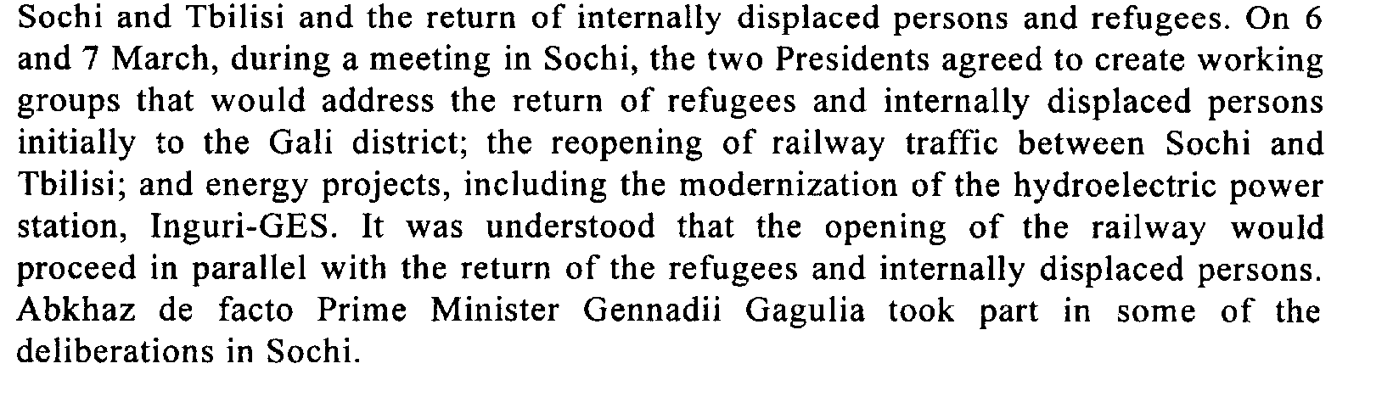

Assessment

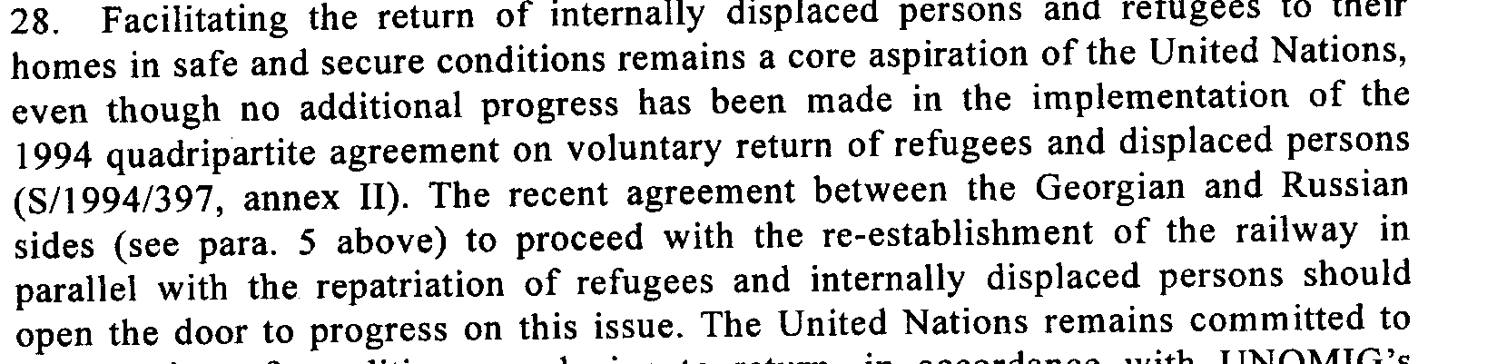

s/2003/412

Short-term compliance
No or marginal compliance (1) | Medium low compliance (2) | Medium high compliance (3) | Full or almost full compliance (4)

Considerations underlying the assessment

Medium-term compliance

Description of the addressee(s)’ conduct
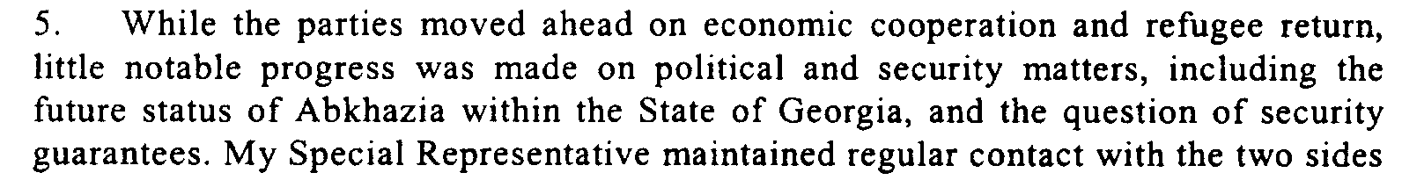
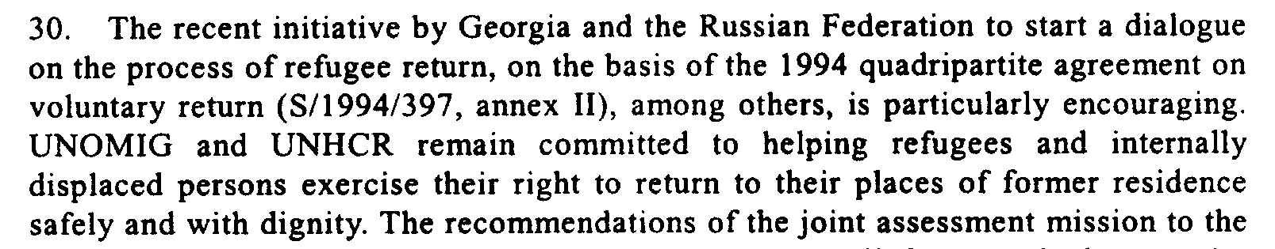

s/2003/751

Assessment

Medium-term compliance
No or marginal compliance (1) | Medium low compliance (2) | Medium high compliance (3) | Full or almost full compliance (4)

Considerations underlying the assessment

Depth of demand

Assessment

Level of depth of demand
Low depth of demand (1) | Medium depth of demand (2) | High depth of demand (3)

Considerations underlying the assessment

Level of confidence about coding decisions

Level of confidence about coding decision
Extremely high | High | Moderate

Comments to IPI (if any)

Civil war in Georgia

UNSC Resolution: | 1462
Date of adoption: | 01/30/03
Operative paragraph: | 14
Demand number: | 1462.1412

David Siroky

Wording of demand

protect returning refugees and displaced persons and to facilitate the return of the reamining displaced population

List of addressees of the demand

Government of Georgia, Abkhazia

Short-term compliance

Description of the addressee(s)’ conduct

s/2003/412

Assessment

Short-term compliance
No or marginal compliance (1) | Medium low compliance (2) | Medium high compliance (3) | Full or almost full compliance (4)

Considerations underlying the assessment

Medium-term compliance

Description of the addressee(s)’ conduct

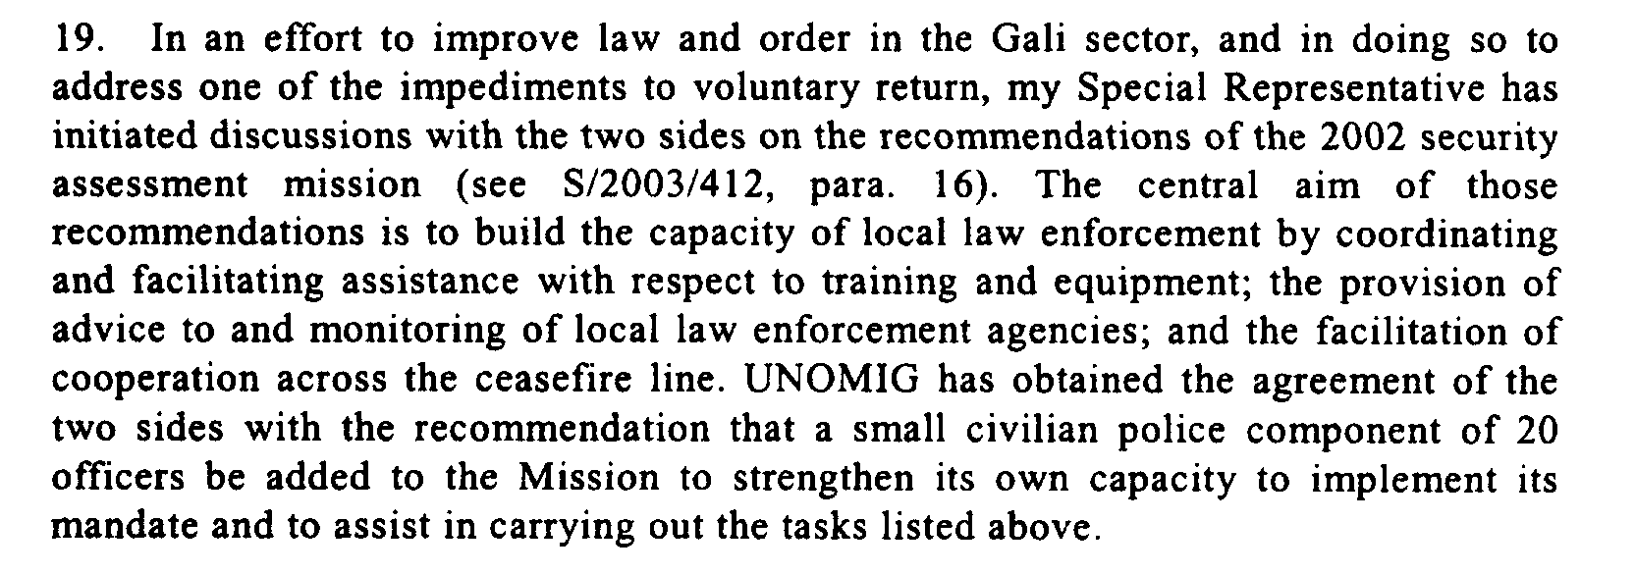

s/2003/412

Assessment

Medium-term compliance
No or marginal compliance (1) | Medium low compliance (2) | Medium high compliance (3) | Full or almost full compliance (4)

Considerations underlying the assessment

Depth of demand

Assessment

Level of depth of demand
Low depth of demand (1) | Medium depth of demand (2) | High depth of demand (3)

Considerations underlying the assessment

Level of confidence about coding decisions

Level of confidence about coding decision
Extremely high | High | Moderate

Comments to IPI (if any)

Civil war in Georgia

UNSC Resolution: | 1462
Date of adoption: | 30 January 2003
Operative paragraph: | 14
Demand number: | 1462.1413

David Siroky

Wording of demand
Make progress on the question of the refugees and internally displaced persons

List of addressees of the demand
Government of Georgia, Abkhazia

Short-term compliance

Description of the addressee(s)’ conduct
In follow-up to the November 2000 joint assessment mission (see S/2001/59, annex II) and as requested by the Coordinating Council’s Working Group II (on internally displaced persons and refugees; see S/2002/1411, para. 18), a security assessment was undertaken in the Gali and Zugdidi sectors. The assessment team consisted of UNOMIG personnel, two officers from the Civilian Police Division of the Department of Peacekeeping Operations and two police monitors with experience in other United Nations missions. The assessment was carried out with the consent and cooperation of the authorities on both sides of the ceasefire line. Preliminary findings identified specific gaps in the organization, training and equipment of the local law enforcement organs. This, together with the absence of a political agreement on the return of refugees, constitutes a deterrent for persons wishing to exercise their right of return and aggravates the already difficult situation of those who have already returned to the Gali area. Enhancement of the rule of law and the administration of justice in the region so as to provide a safe and secure environment for returnees and internally displaced persons is urgently needed. UNOMIG will study the findings and recommendations fo the security assessment upon completion of the team’s full report and will follow up in consultation with the two sides. (Secretary General’s Report, 13 January 2003)

During the period under review, the situation in the Zugdidi sector was calm. Criminal activity was relatively low, with only two killings and five robberies reported by the local authorities. Several peaceful demonstrations took place, mostly by internally displaced persons in protest of their living conditions The local authorities took some steps to improve the situation, in particular the supply of electricity. Since 6 January, a group of internally displaced persons has been blocking the movement of UNOMIG and the CIS peacekeeping force at the main bridge over the Inguri River on the Georgian side. They protest, among other things, the extension of the CIS peacekeeping mandate, the resumption of the rail link between Sochi in the Russian Federation and Sukhumi and the continuing granting of Russian citizenship and Russian passports to residents of Abkhazia. (Secretary General’s Report, 13 January 2003)

The United Nations Human Rights Office in Abkhazia, Georgia, continued to monitor practices of the de facto law enforcement agencies during pre-trial detention and criminal trials and to provide advisory services to the local population, mostly regarding ownership and property rights. It also participated in weekly quadripartite meetings to help address concrete issues of concern to returnees and internally displaced persons (see S/2002/1411, para. 23). (Secretary General’s Report, 13 January 2003)

The return of internally displaced persons to their homes in safe and secure conditions remains a burning issue. Regrettably, no progress has been made in the implementation of the 1994 quadripartite agreement on voluntary return of refugees and displaced persons (S/1994/397, annex II). The report of the joint assessment mission to the Gali district of November 2000 (S/2001/59, annex II) included recommendations for improving the situation, which should be implemented. On the specific issue of strengthening the law enforcement institutions, an assessment mission has been conducted, and I welcome the full cooperation of the two sides as a positive sign of their willingness to improve the situation for returnees and internally displaced persons. (Secretary General’s Report, 13 January 2003)

Assessment

Short-term compliance
No or marginal compliance (1) | Medium low compliance (2) | Medium high compliance (3) | Full or almost full compliance (4)

Considerations underlying the assessment

Medium-term compliance

Description of the addressee(s)’ conduct
In an important step forward, for the first time representative of the Georgian and Abkhaz sides participated in part of the meeting [of the Group of Friends]. Their involvement, in a positive spirit, greatly enhanced the understanding of the GoF on concerns vital to the parties. The sides were committed to further cooperation and agreed to join the GoF again towards the end of the year to review progress and explore further steps. The sides also reacted positively to the suggestion of a joint visit to a post-conflict situation in order to study best practices. Accordingly, UNOMIG has made arrangements to visit Bosnia and Herzegovina and Kosovo, Serbia and Montenegro, in-mid October…At the meeting, the Georgian side stressed the need at present for measures to support and promote the process of return to the Gali district…Abkhaz side stressed in particular its security concerns and the need for a mechanism to ensure the non-resumption of hostilities. It expressed its willingness to constructively address humanitarian questions related to refugee return and to consider the opening of a Gali branch of the human rights office, as well as involvement by the UNHCR in the registration of returnees. (Report of the Secretary-General, October 2003)

The Abkhaz side has shown some positive signs of its commitment to the peace process by attending the high-level meeting in Geneva, engaging in a meaningful dialogue with the Georgian side and the GoF on the issue of security guarantees. (Report of the S-G, Oct. 2003)

Under the leadership of my Special Representative, UNOMIG continued its
efforts on the three sets of issues identified as priority areas for advancing the
Georgian-Abkhaz peace process at the United Nations-chaired high-level meetings
of the Group of Friends, held in Geneva (see S/2004/315, paras. 5-7) — political and
security matters, return of refugees and internally displaced persons and economic
cooperation. In pursuance of this aim, my Special Representative maintained an ongoing
dialogue with both sides at the highest level, as well as with representatives of the
Group of Friends both in Tbilisi and in their capitals. Senior representatives of the
“Friends” — including the Special Representative of the United Kingdom for the
South Caucasus, Sir Brian Fall, the Special Negotiator for Nagorny-Karabakh and
Eurasian Conflicts of the United States of America, Steven Mann, and the Special
Representative of the President of the Russian Federation for the Georgian-Abkhaz
conflict and First Deputy Foreign Minister, Valery Loshchinin — also visited the
region and met with the local leadership in efforts to advance the United Nations-led
peace process. On 29 April, I discussed the situation with the Prime Minister of
Georgia, Zurab Zhvania, in New York. He briefed me on developments in Georgia
and the Government’s efforts to combat crime, including in the zone of conflict. He
reaffirmed Georgia’s commitment to resolve the conflict by peaceful means only.
(Secretary-General Report, July 2004)

I appeal to both parties to seize the new emerging opportunities for dialogue
and to make best use of the involvement of the international community and the
improving regional environment to achieve concrete progress in the agreed priority
areas and related confidence-building measures. In this context, I encourage both
the sides to formally recommit to the non-resumption of hostilities and the peaceful
settlement of the conflict, as well as ensuring the safe and dignified return of
refugees and internally displaced persons, at the first stage to the Gali district. I urge
the Georgian side to be forthcoming to meeting the Abkhaz security concerns and
urge the Abkhaz side to effectively address practical and security concerns of the
local population and returnees and to honour its previous commitments of accepting
the deployment of UNOMIG’s civilian police officers in the Gali district, allowing
the opening of a human rights sub-office in Gali, and the teaching of local youth in
their native Georgian language. (S-G’s Report, July 2005)

Assessment

Medium-term compliance
No or marginal compliance (1) | Medium low compliance (2) | Medium high compliance (3) | Full or almost full compliance (4)

Considerations underlying the assessment

Depth of demand

Assessment

Level of depth of demand
Low depth of demand (1) | Medium depth of demand (2) | High depth of demand (3)

Considerations underlying the assessment

Level of confidence about coding decisions

Level of confidence about coding decision
Extremely high | High | Moderate

Comments to IPI (if any)

Civil war in Georgia

UNSC Resolution: | 1462
Date of adoption: | 01/30/03
Operative paragraph: | 15
Demand number: | 1462.1511

David Siroky

Wording of demand

implement the recommendations of the joint assessment mission to the Gali district, carried out under the aegis of the UN

List of addressees of the demand

Government of Georgia, Abkhazia

Short-term compliance

Description of the addressee(s)’ conduct

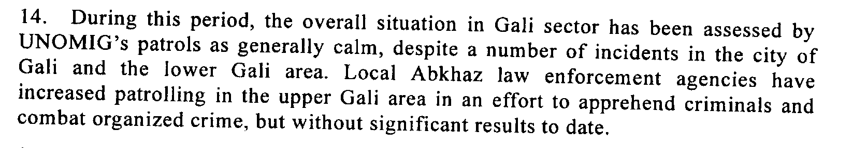
s/2003/412

Assessment

Short-term compliance
No or marginal compliance (1) | Medium low compliance (2) | Medium high compliance (3) | Full or almost full compliance (4)

Considerations underlying the assessment

Medium-term compliance

Description of the addressee(s)’ conduct

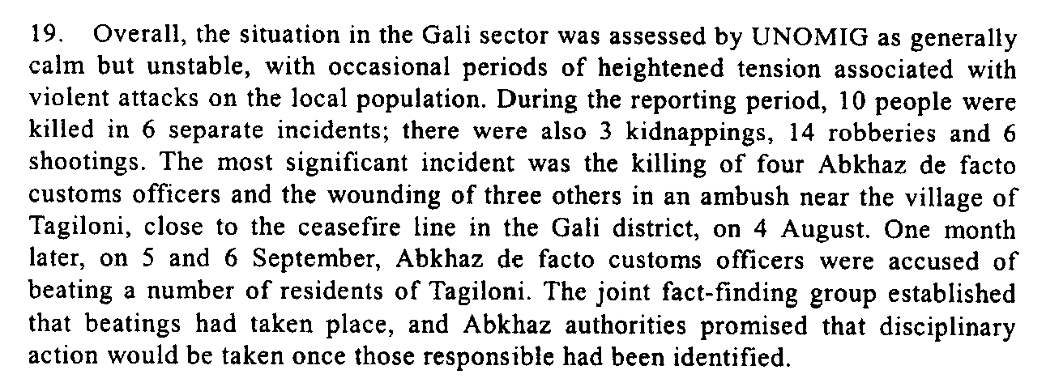
s/2003/1019

Assessment

Medium-term compliance
No or marginal compliance (1) | Medium low compliance (2) | Medium high compliance (3) | Full or almost full compliance (4)

Considerations underlying the assessment

Depth of demand

Assessment

Level of depth of demand
Low depth of demand (1) | Medium depth of demand (2) | High depth of demand (3)

Considerations underlying the assessment

Level of confidence about coding decisions

Level of confidence about coding decision
Extremely high | High | Moderate

Comments to IPI (if any)

Civil war in Georgia

UNSC Resolution: | 1462
Date of adoption: | 01/30/03
Operative paragraph: | 15
Demand number: | 1462.1512

David Siroky

Wording of demand

improve law enforcement involving the local population and address the lack of instruction in Georgian of the local Georgian population

List of addressees of the demand

Government of Georgia, Abkhazia

Short-term compliance

Description of the addressee(s)’ conduct

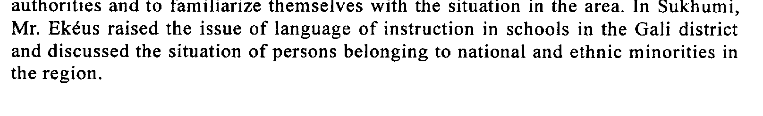
s/2003/412

s/2003/412

Assessment

Short-term compliance
No or marginal compliance (1) | Medium low compliance (2) | Medium high compliance (3) | Full or almost full compliance (4)

Considerations underlying the assessment

Medium-term compliance

Description of the addressee(s)’ conduct

Assessment

Medium-term compliance
No or marginal compliance (1) | Medium low compliance (2) | Medium high compliance (3) | Full or almost full compliance (4)

Considerations underlying the assessment

Depth of demand

Assessment

Level of depth of demand
Low depth of demand (1) | Medium depth of demand (2) | High depth of demand (3)

Considerations underlying the assessment

Level of confidence about coding decisions

Level of confidence about coding decision
Extremely high | High | Moderate

Comments to IPI (if any)

Civil war in Georgia

UNSC Resolution: | 1462
Date of adoption: | 01/30/03
Operative paragraph: | 16
Demand number: | 1462.1611

David Siroky

Wording of demand

publicly dissociate from militant rhetoric and demonstrations of support for military operations and for the activities of illegal armed groups

List of addressees of the demand

Government of Georgia, Abkhazia

Short-term compliance

Description of the addressee(s)’ conduct

NA

Assessment

Short-term compliance
No or marginal compliance (1) | Medium low compliance (2) | Medium high compliance (3) | Full or almost full compliance (4)

Considerations underlying the assessment

Medium-term compliance

Description of the addressee(s)’ conduct

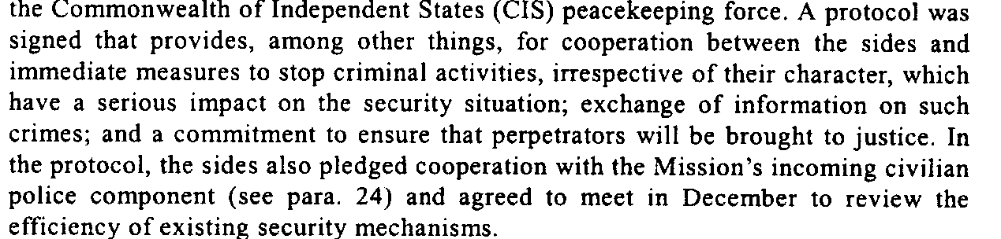
S/2003/1019

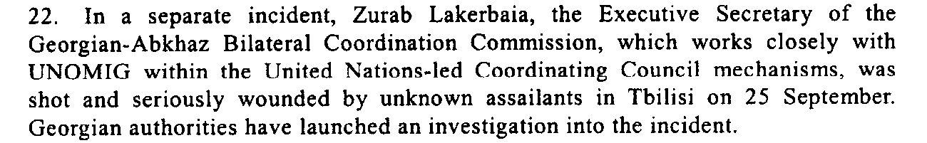

Assessment

s/2003/1019

Medium-term compliance
No or marginal compliance (1) | Medium low compliance (2) | Medium high compliance (3) | Full or almost full compliance (4)

Considerations underlying the assessment

Depth of demand

Assessment

Level of depth of demand
Low depth of demand (1) | Medium depth of demand (2) | High depth of demand (3)

Considerations underlying the assessment

Level of confidence about coding decisions

Level of confidence about coding decision
Extremely high | High | Moderate

Comments to IPI (if any)

Civil war in Georgia

UNSC Resolution: | 1462
Date of adoption: | 01/30/03
Operative paragraph: | 16
Demand number: | 1462.1612

David Siroky

Wording of demand

continue efforts to put an end to the activities of illegal armed groups

List of addressees of the demand

Government of Georgia, Abkhazia

Short-term compliance

Description of the addressee(s)’ conduct

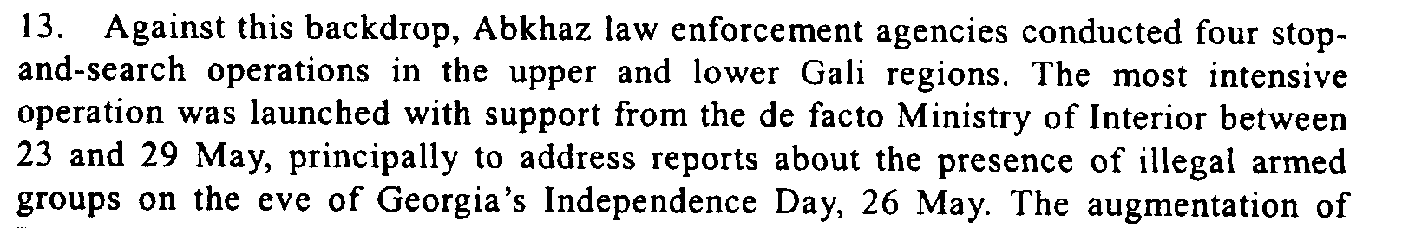
s/2003/412

Assessment

Short-term compliance
No or marginal compliance (1) | Medium low compliance (2) | Medium high compliance (3) | Full or almost full compliance (4)

Considerations underlying the assessment

Medium-term compliance

Description of the addressee(s)’ conduct

s/2003/412

s/2003/412

Assessment

s/2003/1019

Medium-term compliance
No or marginal compliance (1) | Medium low compliance (2) | Medium high compliance (3) | Full or almost full compliance (4)

Considerations underlying the assessment

Depth of demand

Assessment

Level of depth of demand
Low depth of demand (1) | Medium depth of demand (2) | High depth of demand (3)

Considerations underlying the assessment

Level of confidence about coding decisions

Level of confidence about coding decision
Extremely high | High | Moderate

Comments to IPI (if any)

Civil war in Georgia

UNSC Resolution: | 1462
Date of adoption: | 01/30/03
Operative paragraph: | 17
Demand number: | 1462.1711

David Siroky

Wording of demand

take all necessary steps to identify those responsible for the shooting down of a UNOMIG helicopter on 8 October 2001 and bring them to justice as well as inform the Special Representative on the implementation of these steps

List of addressees of the demand

Government of Georgia, Abkhazia

Short-term compliance

Description of the addressee(s)’ conduct

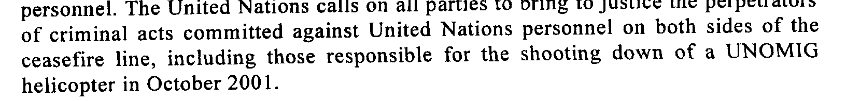

Assessment
S/2003/412

Short-term compliance
No or marginal compliance (1) | Medium low compliance (2) | Medium high compliance (3) | Full or almost full compliance (4)

Considerations underlying the assessment

Medium-term compliance

Description of the addressee(s)’ conduct

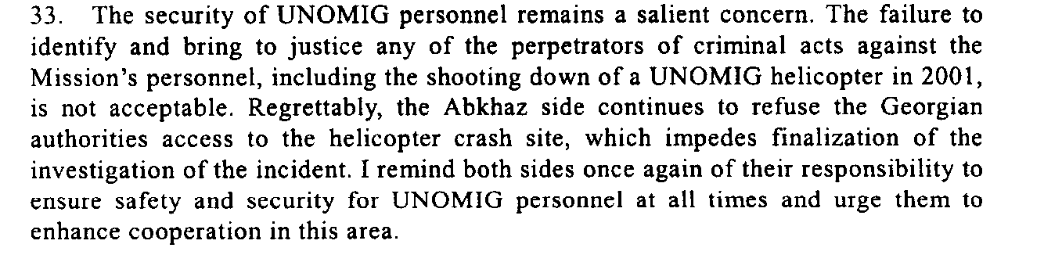

Assessment

s/2003/1019

Medium-term compliance
No or marginal compliance (1) | Medium low compliance (2) | Medium high compliance (3) | Full or almost full compliance (4)

Considerations underlying the assessment

Depth of demand

Assessment

Level of depth of demand
Low depth of demand (1) | Medium depth of demand (2) | High depth of demand (3)

Considerations underlying the assessment

Level of confidence about coding decisions

Level of confidence about coding decision
Extremely high | High | Moderate

Comments to IPI (if any)

Civil war in Georgia

UNSC Resolution: | 1462
Date of adoption: | 01/30/03
Operative paragraph: | 18
Demand number: | 1462.1811

David Siroky

Wording of demand

provide appropriate security and ensure the freedom of movement of UNOMIG, the CIS peacekeeping force and other international personnel

List of addressees of the demand

Government of Georgia, Abkhazia

Short-term compliance

Description of the addressee(s)’ conduct

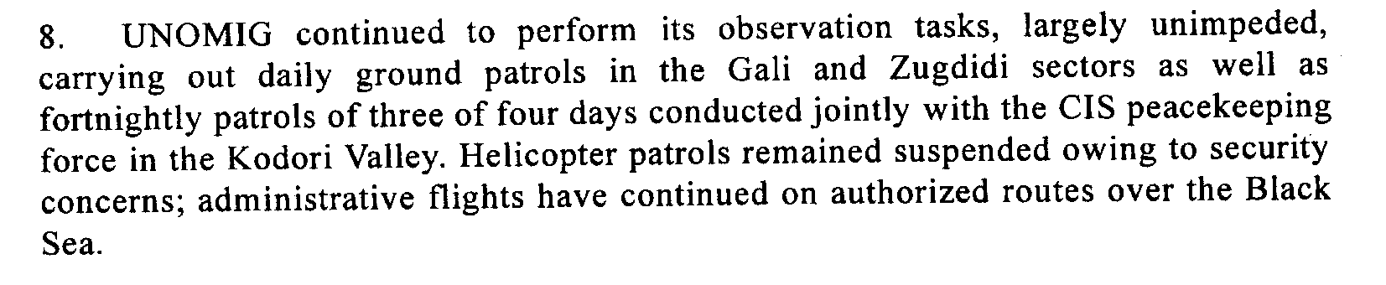
S/2003/412

Assessment

Short-term compliance
No or marginal compliance (1) | Medium low compliance (2) | Medium high compliance (3) | Full or almost full compliance (4)

Considerations underlying the assessment

Medium-term compliance

Description of the addressee(s)’ conduct

Assessment

s/2003/1019

Medium-term compliance
No or marginal compliance (1) | Medium low compliance (2) | Medium high compliance (3) | Full or almost full compliance (4)

Considerations underlying the assessment

Depth of demand

Assessment

Level of depth of demand
Low depth of demand (1) | Medium depth of demand (2) | High depth of demand (3)

Considerations underlying the assessment

Level of confidence about coding decisions

Level of confidence about coding decision
Extremely high | High | Moderate

Comments to IPI (if any)

